# 📘 Project Documentation: Personal Portfolio Website

## 1. Overview

This is a **personal portfolio website** designed and developed by and for **Patrick Kariuki**, a **Data Analyst and Web Developer**.
The portfolio serves as a digital resume, showcasing professional skills, certifications, projects, and achievements in a visually appealing and responsive manner.

The project is built using **HTML, CSS, and JavaScript**, and deployed using **GitHub Pages** for free hosting.

---

## 2. Objectives
- ✅ Create an **online presence** for professional branding.
- ✅ Provide a **central hub** to showcase projects, skills, and certifications.
- ✅ Ensure the site is **responsive**, accessible across desktop, tablet, and mobile devices.
- ✅ Implement **modern design principles** with animations and transitions.
- ✅ Enable potential employers, clients, and collaborators to **connect easily** via a contact form.

---

## 3. Features
- **Home Page** – Hero section with animated background, introduction, and highlights.
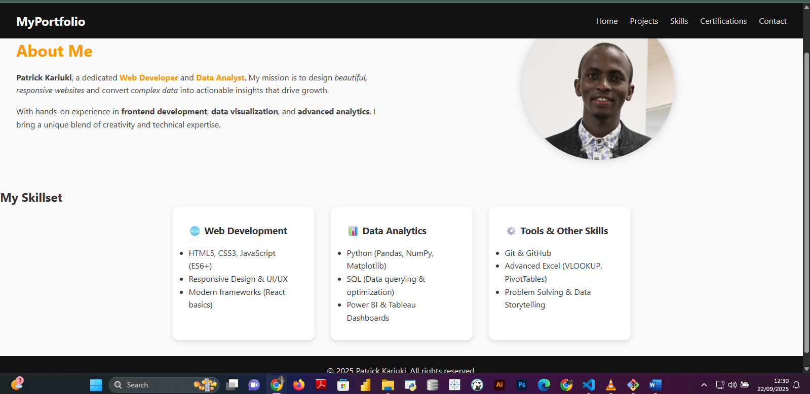
- **About Page** – Personal story, career journey, and professional summary.

- **Projects Page** – Portfolio of completed and ongoing projects with descriptions.
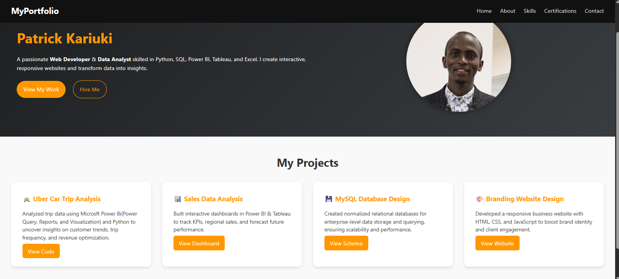
- **Skills Page** – Technical and analytical skills presented in **card-based design**.
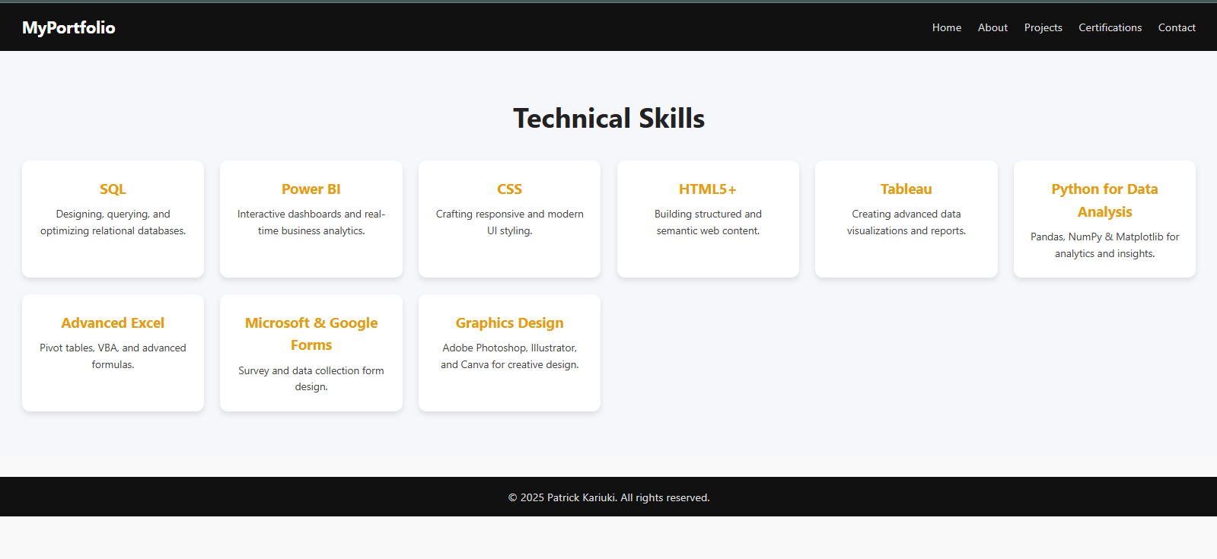
- **Certifications Page** – Display of completed certifications such as:
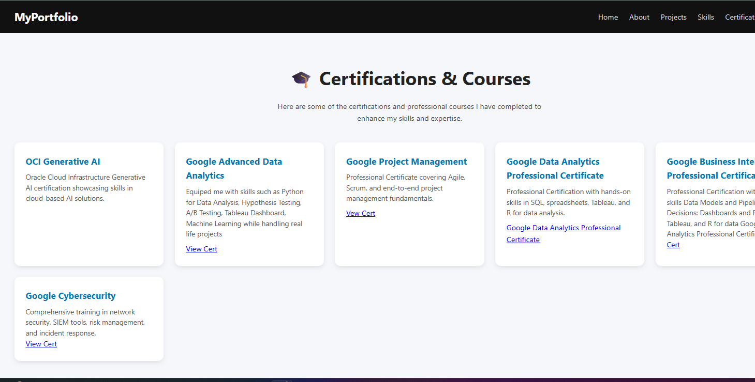
- OCI Gen AI
- Google Data Analytics Professional Certificate
- Google Cybersecurity Professional Certificate
- Google Business Intelligence Professional Certificate
- Google Project Management Certificate
- Cisco CyberOps
- **Contact Page** – Contact form with input validation (JS) for collecting inquiries.
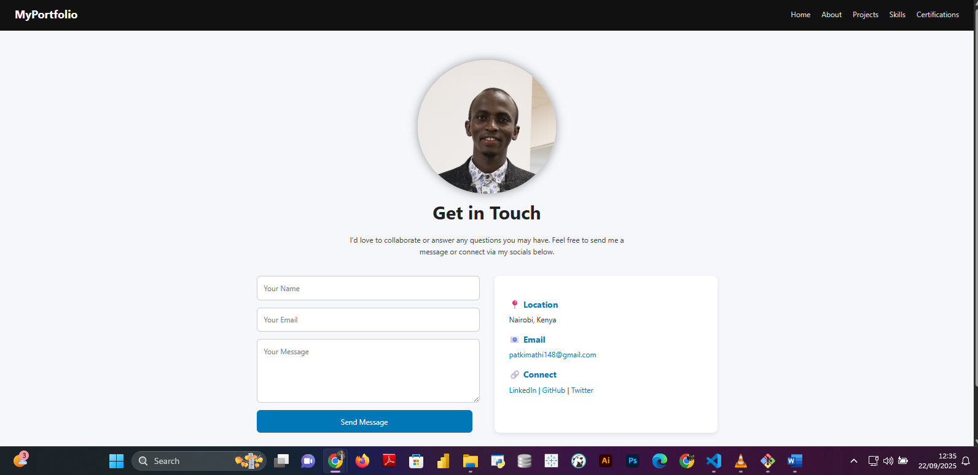
- **Responsive Navigation Bar** – Dropdown menu for small screens with hamburger toggle.
- **Animations & Transitions** – Motion background, smooth hover effects, and fade-in sections.

---

## 4. Technologies Used
### Frontend
- **HTML5** – Structure and semantic markup.
- **CSS3** – Styling, animations, responsive layout (media queries, flexbox, grid).
- **JavaScript (ES6+)** – DOM manipulation, form validation, navbar toggle, animations.

### Tools & Platforms
- **Git & GitHub** – Version control and repository hosting.
- **GitHub Pages** – Free deployment platform.
- **VS Code** – Code editor for development.

---

## 5. Project Structure
```bash
portfolio-website/
│
├── index.html # Home Page
├── about.html # About Me
├── projects.html # Projects
├── skills.html # Skills
├── certifications.html # Certifications & Courses
├── contact.html # Contact Page
│
├── css/
│ └── style.css # Stylesheet
│
├── js/
│ └── script.js # JavaScript functionality
│
├── images/ # Profile and project images
│
├── README.md # Project summary
└── DOCUMENTATION.md # Detailed project documentation (this file)
```

---

## 6. Installation & Setup

### Option 1 – Run Locally
1. Clone the repository:
```bash
git clone https://github.com/your-username/portfolio.git
cd portfolio
```
2. Open `index.html` in your browser.

### Option 2 – Live Deployment
The website is hosted on **GitHub Pages**:
```
https://your-username.github.io/portfolio/
```

---

## 7. How to Contribute
This is a personal portfolio project, but contributions can include:
- Bug fixes in code.
- Suggestions for better design or performance improvements.
- Adding dark/light theme toggle.

Fork the repo, create a feature branch, and submit a pull request.

---

## 8. Future Enhancements
- 🌙 **Dark/Light mode toggle** for accessibility.
- 📩 **Backend integration** for the contact form (Node.js, Firebase, or Formspree).
- 🌐 **Multilingual support** (English + Swahili).
- 📊 **Blog Section** to share insights on Data Analytics and AI.
- 🔐 **Enhanced Security** with input sanitization and reCAPTCHA for the contact form.

---

## 9. License
This project is licensed under the **MIT License** – free to use, modify, and distribute with attribution.

---

## 10. Author
👤 **Patrick Kariuki**
- 💼 Data Analyst | Web Developer |UI UX Designer

- 📧 Email: patkimathi148@gmail.com

- 🌍 Portfolio: https://patrickkimathi.github.io/patrickkimathi.github.io-my-portfolio

- 🔗 LinkedIn: https://www.linkedin.com/in/patrick-kariuki-5914b7186/

